CSE 420

Assignment 01

Deadline: 25/05/2016

1. Convert following DFA to RE :

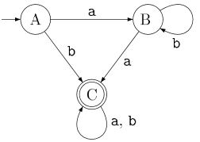

1. Convert following NFA to DFA using Subset Construction method.

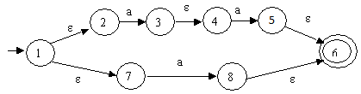

1. Convert following DFA to RE :

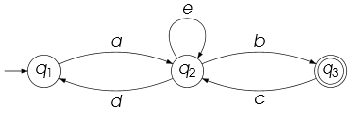

1. Convert following NFA to DFA using subset construction methodology.

